About the Management
Patle Tilak Vidyalaya Association:
A learned scholar, a great mathematician, philosopher, teacher and orator, Lokmanya Bal Gangadhar Tilak left for his heavenly abode on 1st August 1920. A group of eminent personalities and other residents of Parle made a commitment that they would continue the great work of Lokmanya Tilak . As the first step in this direction, they decided to start a school in Vile Parle. Thus on 9th June 1921, Parle Tilak Vidyalaya Associations Marathi Medium School began in One room with just 7 students. Eventually, Parle Tilak Vidyalaya (Marathi Medium) Primary and Secondary School was started in 1923.In June 2017 Parle Tilak Vidyalaya Association’s English Medium School (SSC curriculam ) was started at Andheri.
The local stalwarts from Vile Parle contributed generously, despite difficult times to construct the school buildings. The Students strength increased and the management soon realized the need for facilities for higher education beyond school level. This led to the establishment of Parle College of Science and Arts in 1959.
The management soon felt that a Science and Arts College was not enough. In order to meet the growing demand for Commerce , the Parle College of Commerce was started in 1960 which was later named "M.L.Dahanukar College of Commerce". The Parle Tilak Vidyalaya Association also made its presence felt in the central suburbs when it started " Mulund College of Commerce " in 1970. Also in 1970, in a nearby suburb Andheri . Parle TilakVidylaya Association opened another Marathi Medium school, named as " Paranjape Vidyalaya " both Primary and Secondary School. Very soon, that school also became a force to reckon with students featuring regularly in the merit lists.

About the College:
PTVA’s Mulund College of Commerce is proud to be a part of this rich educational legacy. Established in 1970, in a very short period of time, Mulund College of Commerce emerged as one of the most prestigious commerce colleges of suburban Mumbai. MCC has excelled in all aspects of in higher education. Our results at the Higher Secondary Certificate examination and the Final Year University examinations have always been excellent. It has been one of the most sought-after colleges, not only for excellence in academics but also in co-curricular and extra-curricular activities. Our students have performed exceedingly well in professional courses securing All India Ranks in such examinations. Our alumni hold prominent positions in the Banking and Financial sectors, in the Indian judicial system and in the sphere of media and entertainment. The college has produced eminent sportspersons of whom nine have been the recipients of the Shiv Chhatrapati Awards. Our students played at the National and represented India in competitions at International levels.
MCC embraced the Self Financing Courses when it was newly introduced in the last decade of the twentieth century. Today, MCC boasts of a very strong Self Financing section offering courses in Accounting and Finance, Banking and Insurance, Financial Markets, Management Studies, Mass Media, Computer Science and Information Technology.

Patron’s Message:
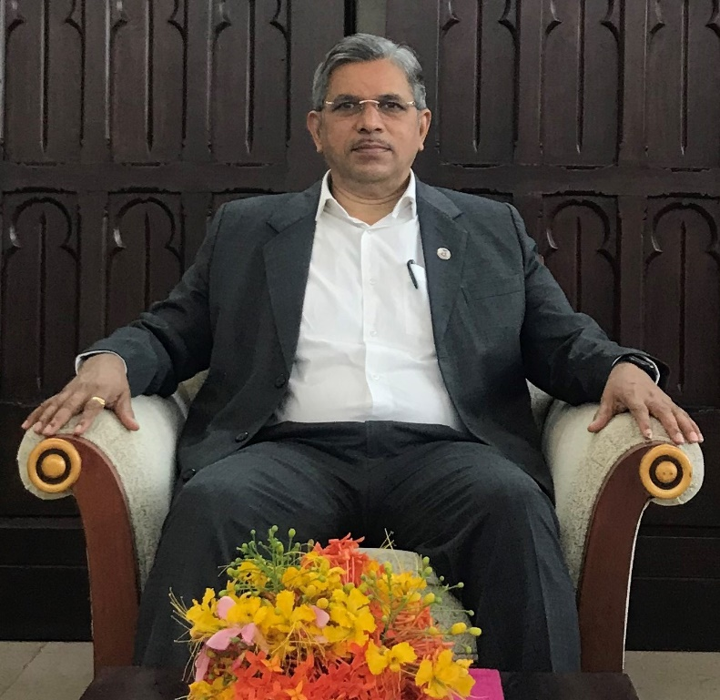
Prof. Suhas Pednekar
Vice Chancellor
University of Mumbai and Dr. Homi Bhabha State University (HBSU)

We are in the fourth revolution where the human skills are rapidly being replaced by automation through AI. This brings the label “Agile Human” into picture that refers to people with physical dexterity and agility. Manual tasks that cannot be automated require capabilities out of reach by machines. We should now find steps in which we stay one step ahead of AI. People should effectively use AI rather than using it mindlessly and becoming slaves to AI. Famous personalities like Sophia the robot, and Elon Musk make headlines regularly. Since this platform has us gathered here today, there is a lot to get enlightened by.

The four themes of the Conference reflect that the departments of CS and IT are making the conscious effort of keeping up with the pace in technological advancements. There is a plethora of research out there. With platforms like these that provide an opportunity to bring out and present the areas of interest, conferences like CyProbe 2020 are intellectual successes. We hope that the participants will gain insights and promote new ideas in the society. I extend my best wishes to all and wish you a successful conference.

Principal’s Message:
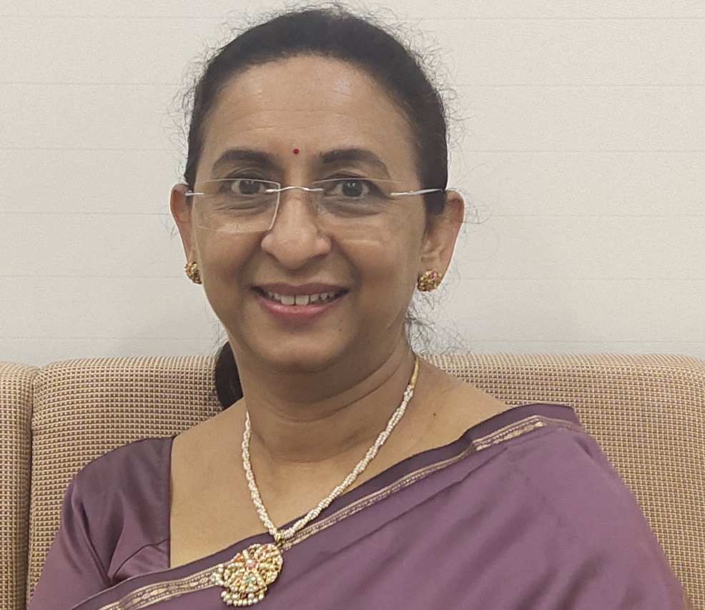

In this golden jubilee year of our college, we have planned and implemented a host of events. Two Memorial lectures – Dr. B.G. Bapat Memorial Lecture Series and Tilak Smruti Vyakhyana were launched. All departments of the college organized various inter-collegiate events to enrich the academic environment. The Golden Dream Run was held to engage with the society. The other events include the Yuva Sahitya Sammelan to popularize cultural values among the youth.
The Departments of Computer Science and Information Technology have made conscious efforts to keep pace with the rapidly changing world. Going beyond the call of duty, the faculty have motivated students to perform to their full potential and enjoy the process of knowledge enhancement. This national conference on Advanced Research in Computer Science and Information Technology - CyProbe is a continuation of our commitment to the cause of holistic education. The conference explores four major areas – Networking and cloud, Application of Information Technology, Artificial Intelligence and Core Computing. In a world of technological advances, these thrust areas will open new avenues for research and newer skill sets for the years to come.
It gives me immense pleasure in wishing well for this National Conference organized by the Departments of Computer Science and Information Technology of our college.
About the conference:
Conferences such as CyProbe 2020 - A National Conference on Advances Research in Computer Science and Information Technology provide a valuable opportunity for enthusiastic students, research scientists, industry specialists and decision-makers to share experiences. They bring together people from all different geographical areas who share a common discipline or field, and they are a great way to meet new people in your field. Such platforms are essential for building a strong network and enlightening our minds with the presentations on various fields. CyProbe 2020 is one that brings research diversity in regards to computer applications. It allows the participants to build on their ideas, research, develop knowledge in their field and finding solutions to problems. The themes of CyProbe 2020 revolve around Networking and Cloud, Applications of Information Technology, Intelligent Systems and Core Computing. These are presented with the hopes of giving and receiving exciting new insights. Speakers at CyProbe 2020 will establish themselves in their respective fields of study and the attendees will be united by the multidisciplinary topics. The focused nature of learning at this conference will allow you to dig deeper with the understanding of your topic of interest.

Conference Committee:
Our Patrons
Prof. Suhas Pednekar  Vice Chancellor,  University of Mumbai and Dr. Homi Bhabha State University | Shri Anil B Ganu  President, PTVA
Shri Vinay S Jog  Vice President, PTVA | Shri Dilip M Pethe  Hon. Secretary, PTVA
Shri Hemant K. Bhatawadekar  Hon. Jt. Secretary, PTVA | Shri Bansidhar Sadashiv Dhurandhar Hon. Treasurer, PTVA
Advisory Committee
Dr. K. G. Bhole  Vice Principal (Emeritus),  KET’s V. G. Vaze College | Dr. (Smt.) R. Srivaramangai  Head, University Department of Information Technology,  University of Mumbai
Dr. Rajendra Patil  Coordinator, Department of Information Technology,  S. K. Somaiya College | Dr. Santosh Singh  Coordinator, Department of Information Technology, Thakur College of Science and Commerce
Dr. Tushar Sambare  Coordinator, Department of Information Technology, S. M. Shetty College | Mr. Abhijeet Kale  Coordinator, Department of Information Technology,  B. N. Bandodkar College
Mr. Prakash Patil  Coordinator, Department of Information Technology, K. J. Somaiya College of Science and Commerce | Mrs. Pournima Bhangale  Coordinator, Department of Information Technology,  KET’s V. G. Vaze College
Organizing Committee
Dr. Sonali Pednekar  Principal | Dr. K. G. Rajan  Vice Principal
Dr. Hiren Dand  Co-ordinator  Department of Information Technology | Ms. Reena Shah  Co-ordinator  Department of Computer Science
Mrs. Shilpa Thakur  Co-ordinator  Department of accounting and Finance, Banking and Insurance and Financial Markets | Mrs. Vijayalakshmi Kannan  Co-ordinator  Department of Management Studies and Media Studies
Ms. Jyotika Chheda  Assistant Professor | Ms. Vaishnavi Assar  Assistant Professor
Ms. Priti Pathak  Assistant Professor | Ms. Pooja Patil  Assistant Professor
Mr. Vishal Borude  Assistant Professor | Ms. Shylashree Dev  Assistant Professor
Mr.Jojan Mathai  Assistant Professor | Ms. Bhumika Nakum  Assistant Professor
Mr. Sanketh Iyer  Assistant Professor | Ms. Pratiksha Harwalkar  Assistant Professor

